BULIDING A FACE DETECTION AWS APP

AWS:

* AWS login page
* EC2 dashboard
* S3 dashboard
* Rekogination dashboard

Aws login page:

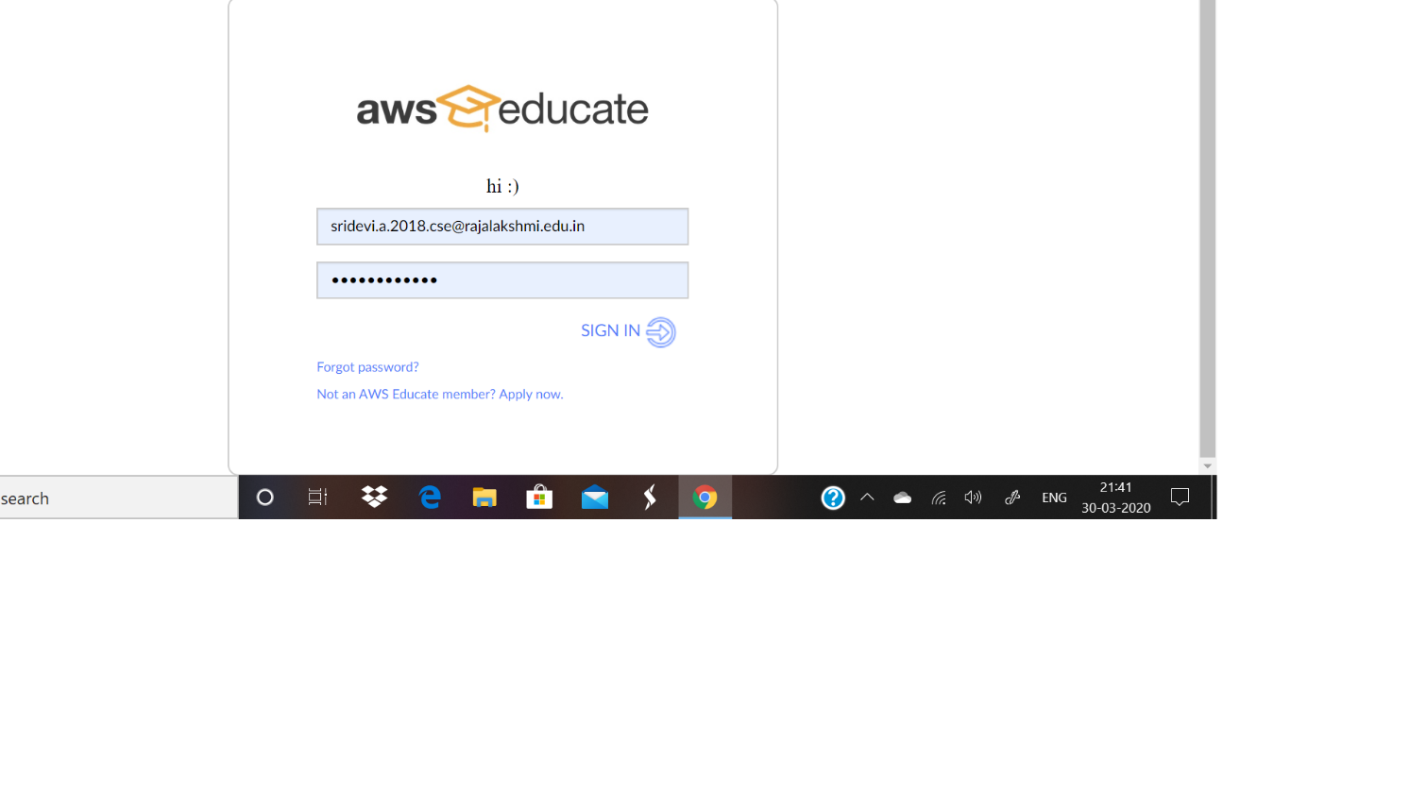

EC2dashboard:

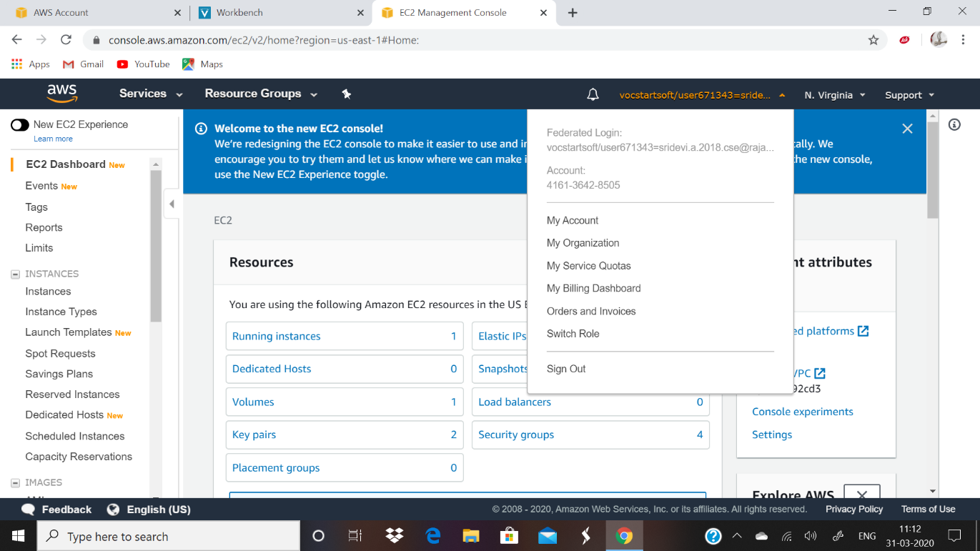

Rekognition dashboard:

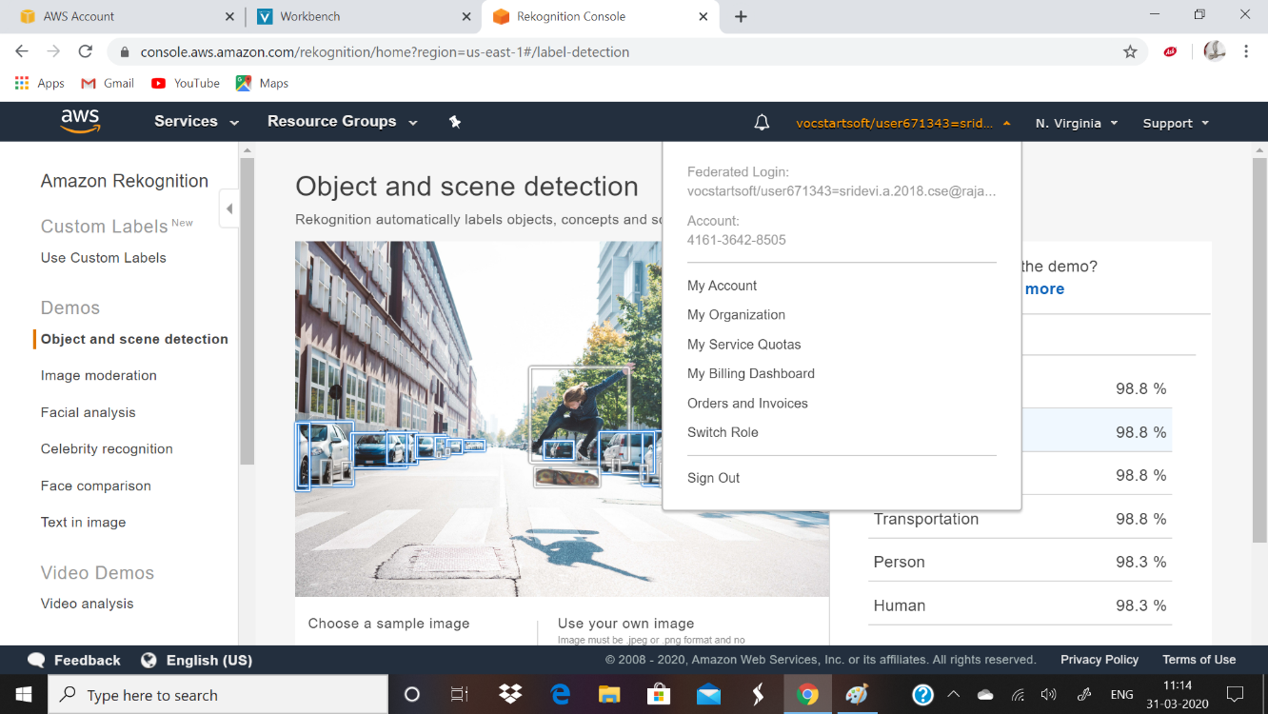

S3 dashboard:

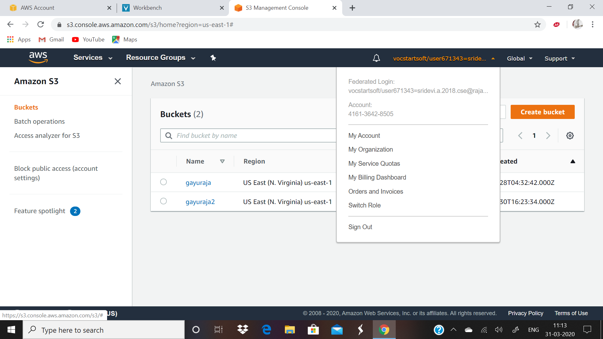

EC2:

* Choosing a AMI
* Choosing a instance type
* Adding storage
* Configuring a security group
* Key pair download
* puTTYgen conversion from .pem to .ppk
* logged in EC2 black screen

Choosing a AMI:

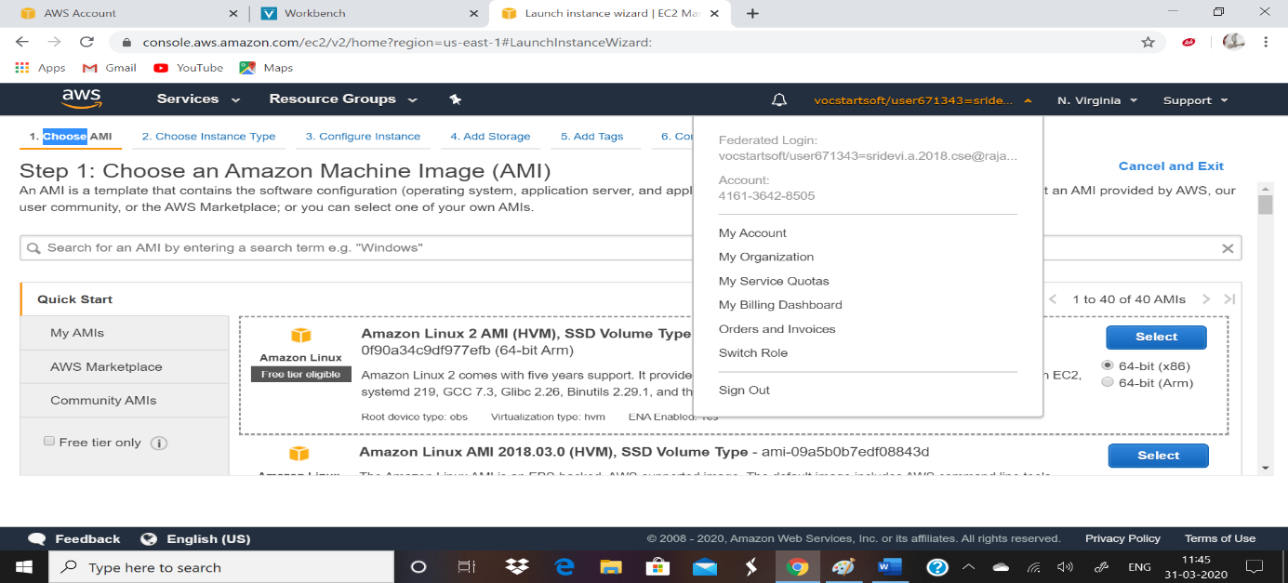

Choosing an instance type:

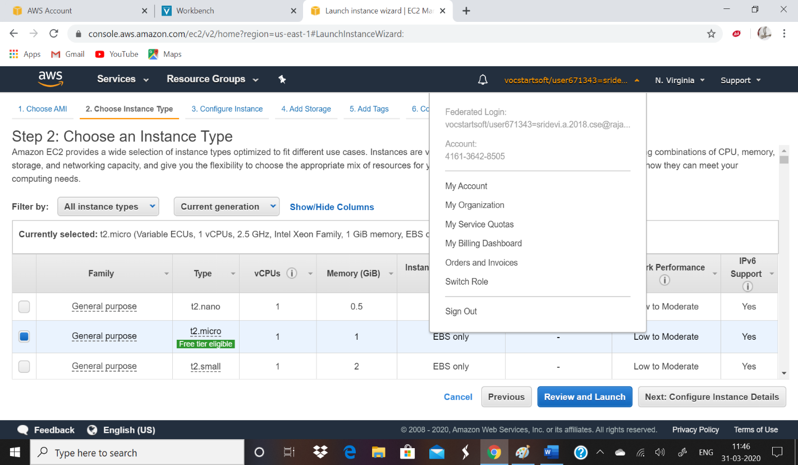

Configuring security group:

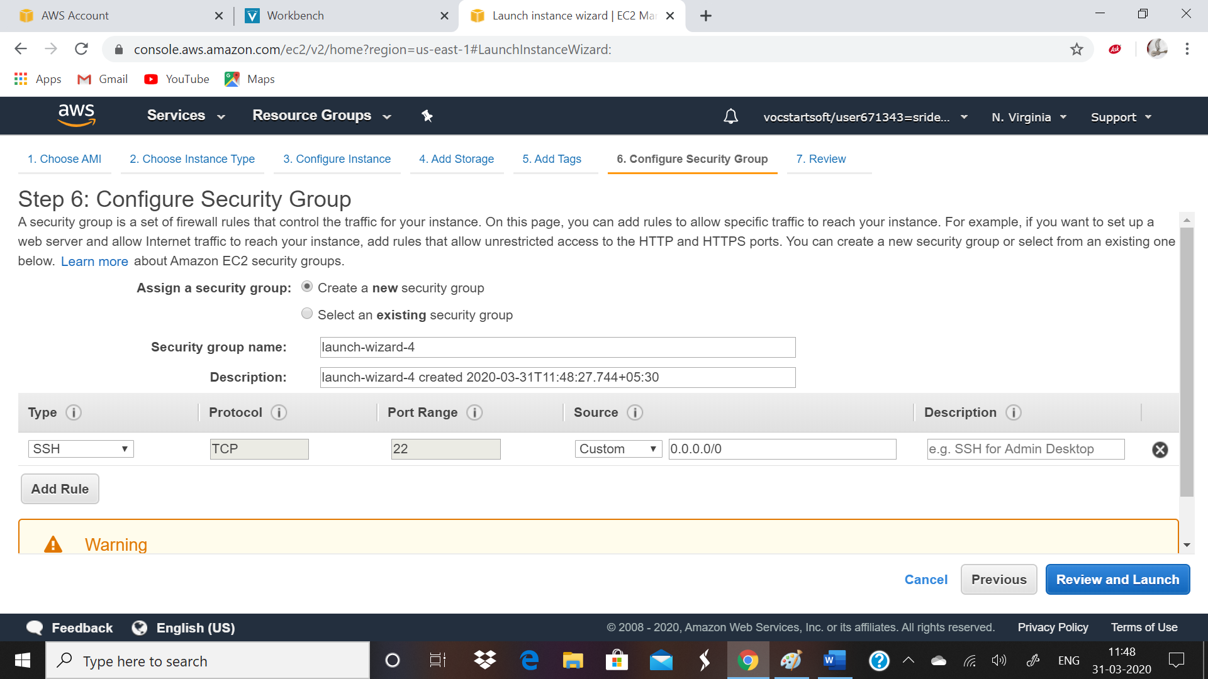

Keypair download:

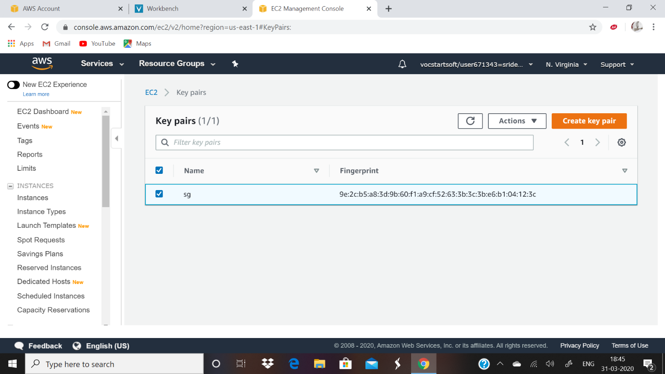

puTTEYgen conversion from .pem to,ppk file:

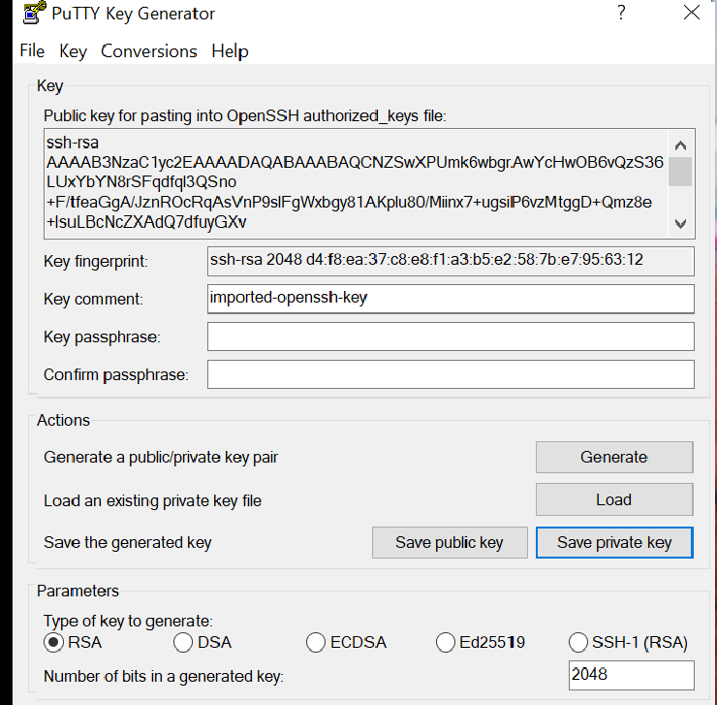 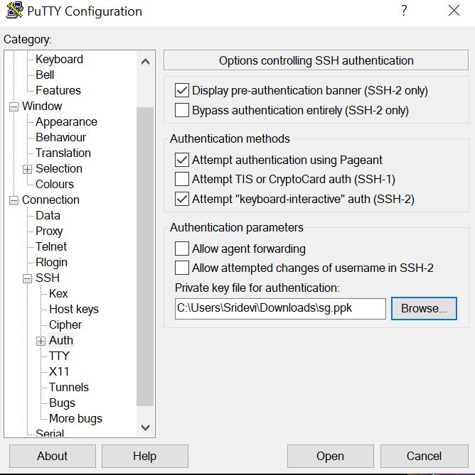

Logged in EC2 screen:

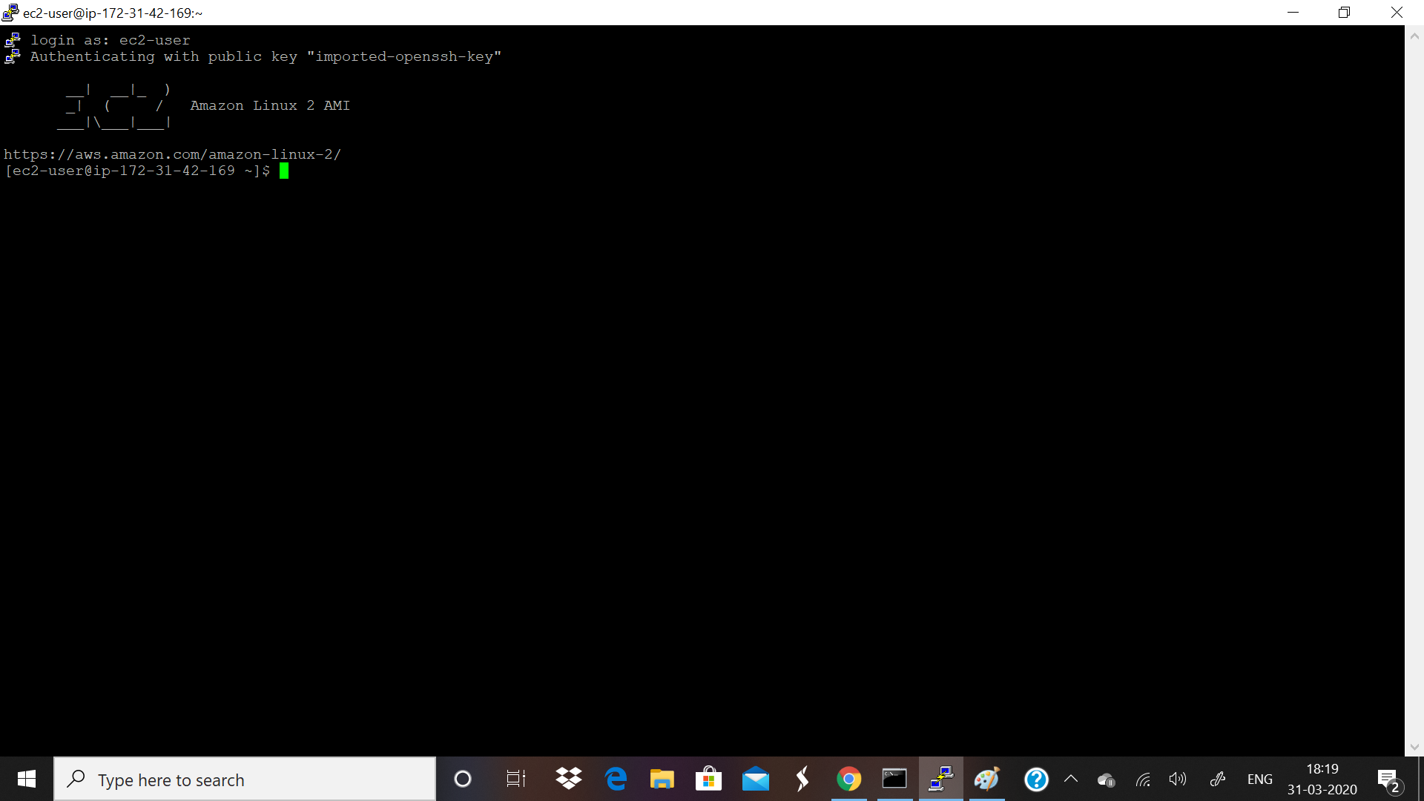

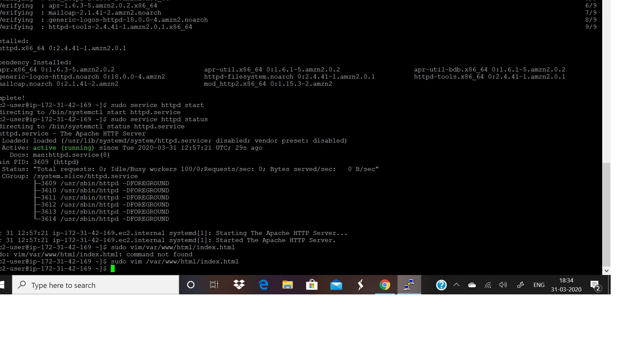

S3:

* Create bucket
* Uploading an object
* Enabling static website
* Making object as public
* Checking the S3 browser

Creating bucket:

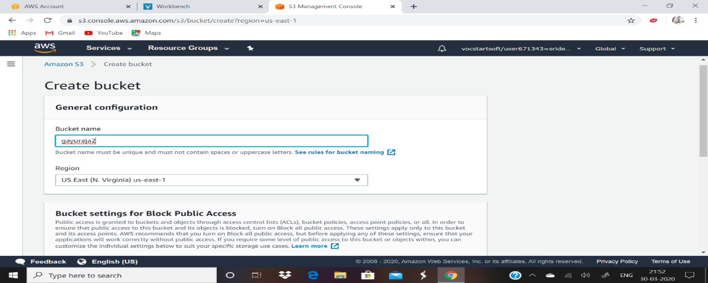

Uploading object:

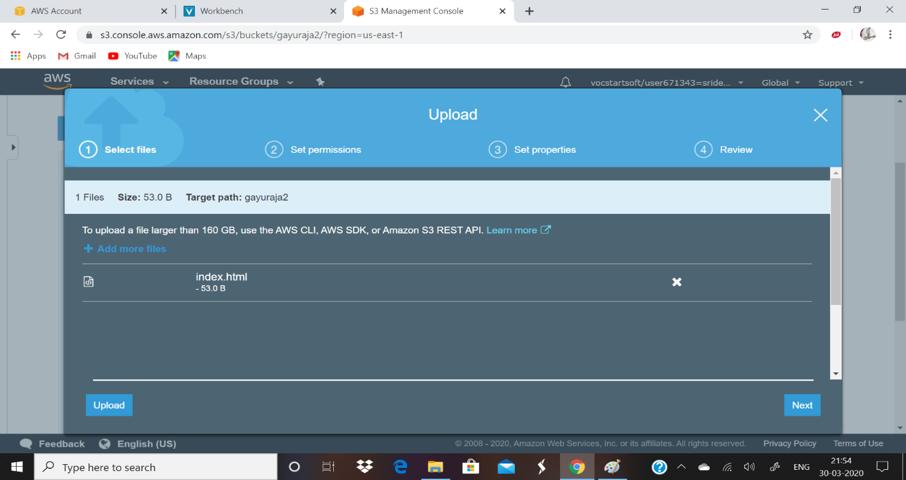

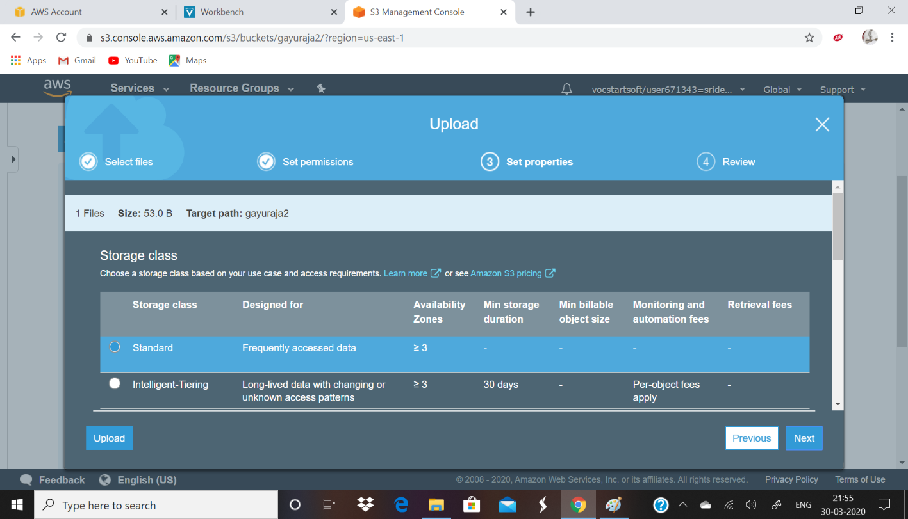

Enabling static website:

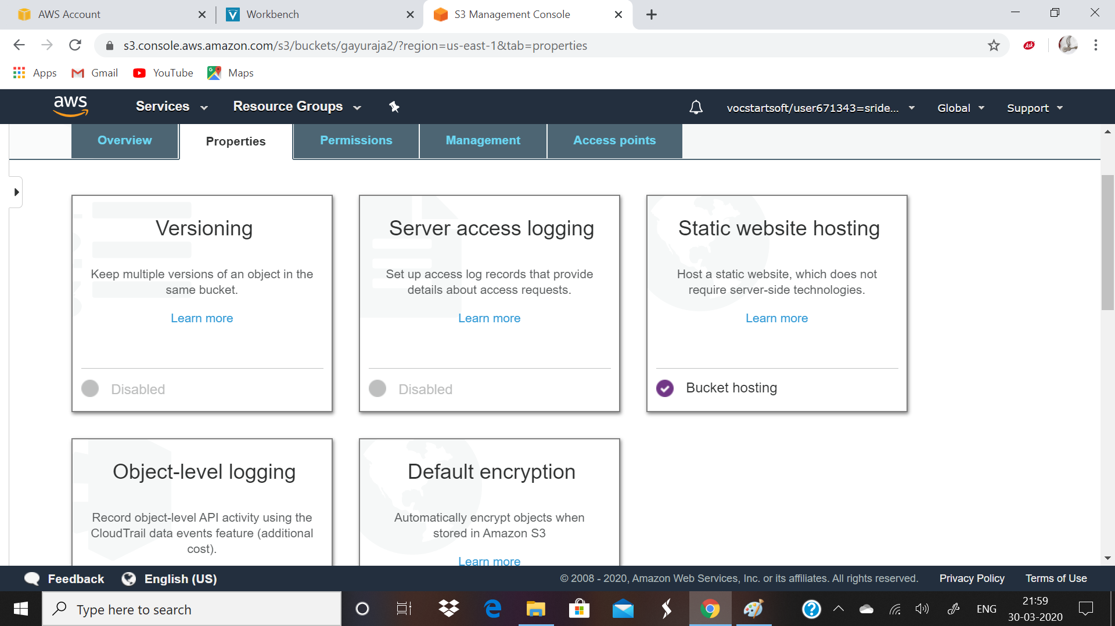

Making object as public:

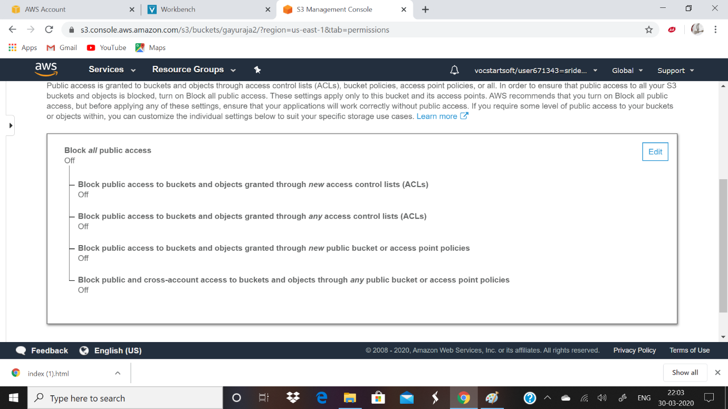

Checking the S3 browser:

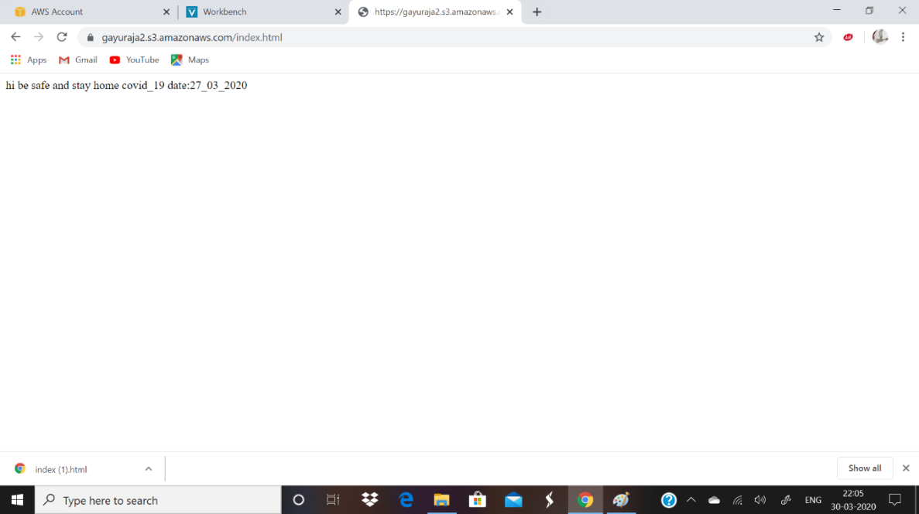

Rekognination:

* Face dectection
* Face compare
* Celebrity rekognination
* Text in image

Face dectection:

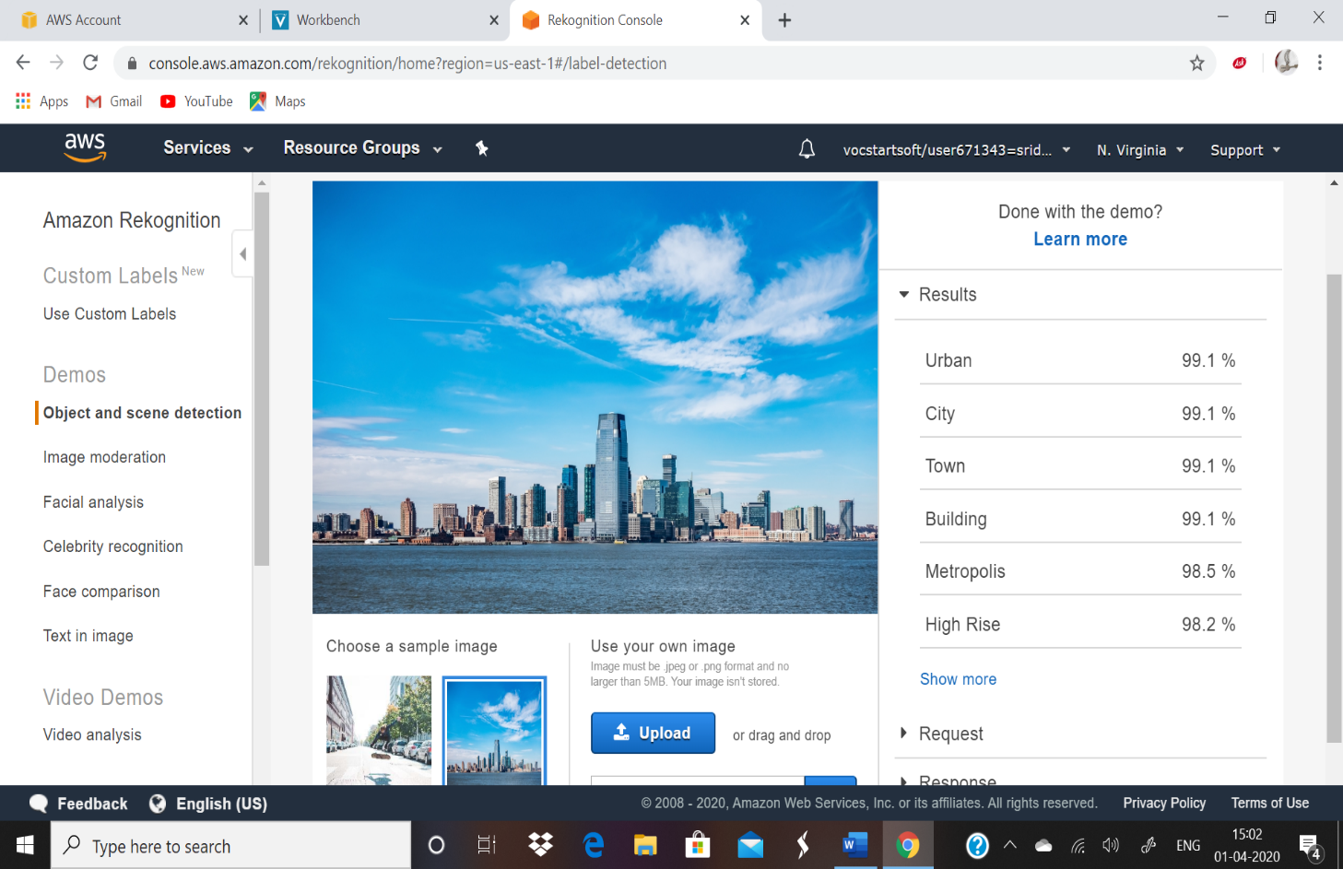

Face compare:

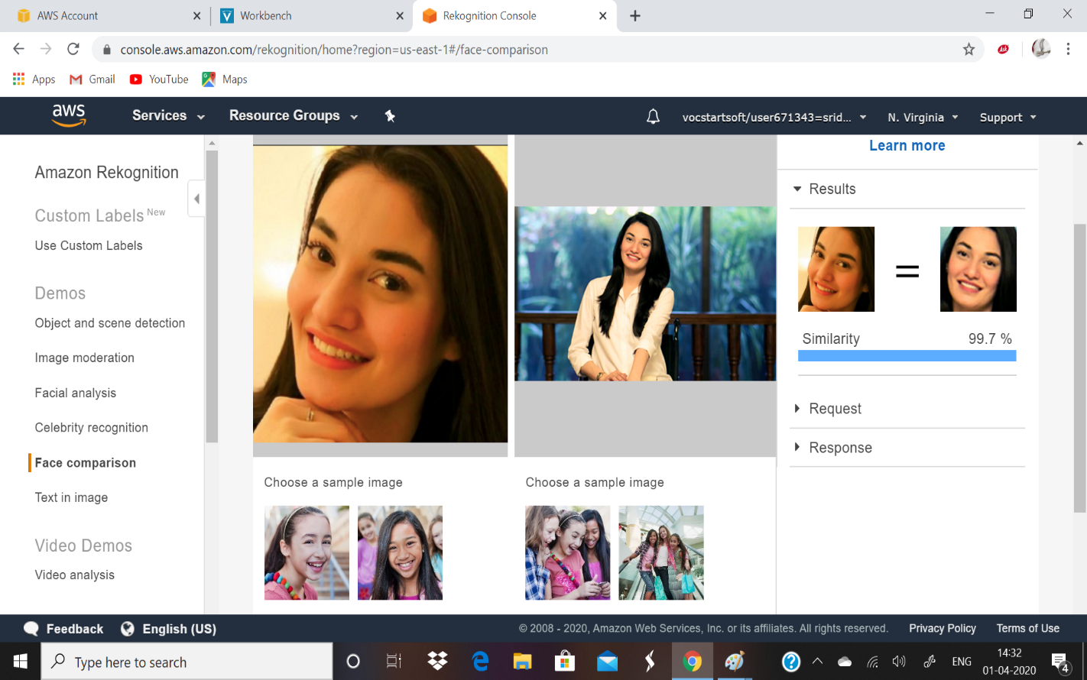

Celebrity Rekoginition:

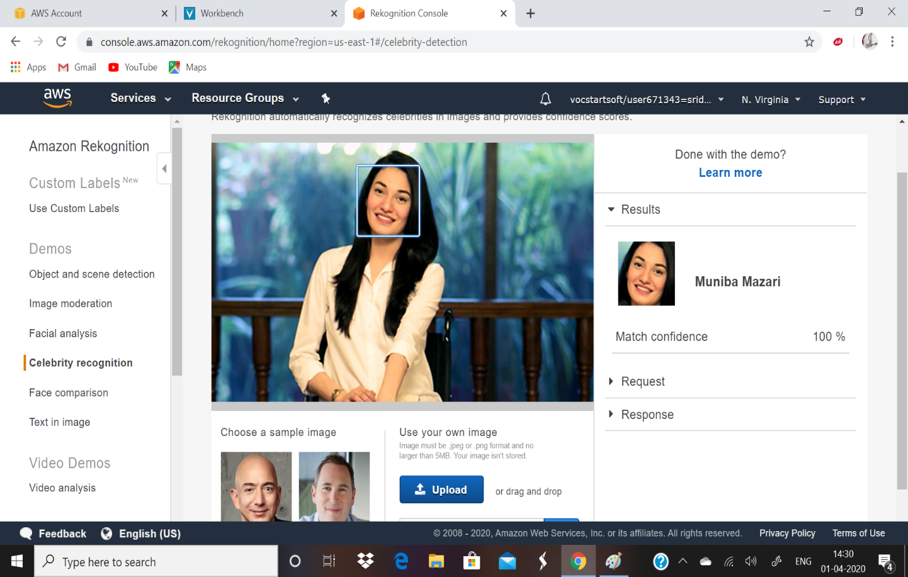

Text in image:

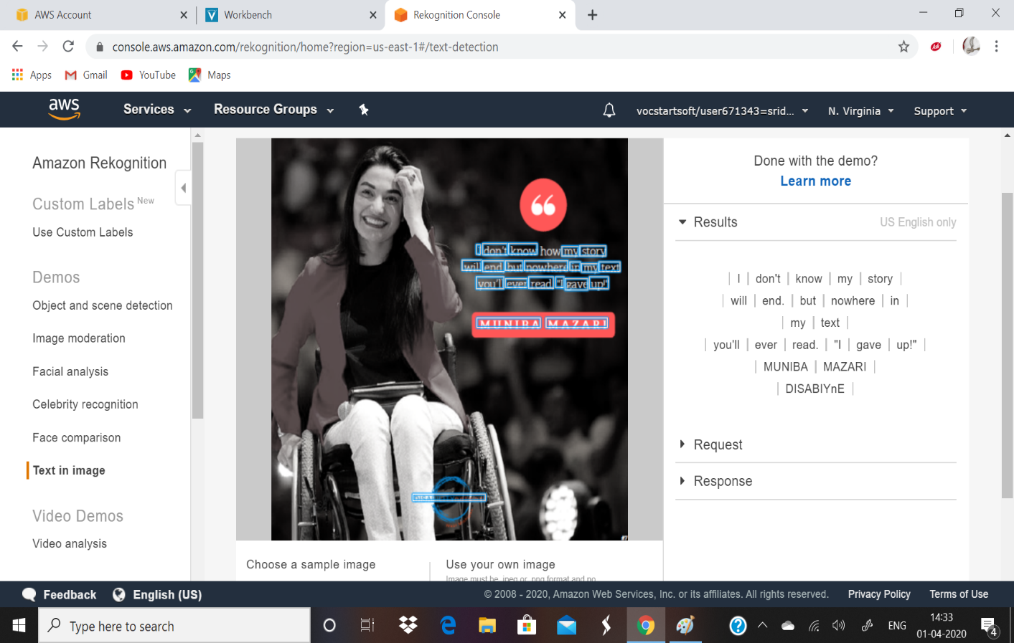

Ec2 and S3:

* Installing aws.sdk
* Installing php
* Index .php file code
* Uploaded Successfully

Installing aws.sdk:

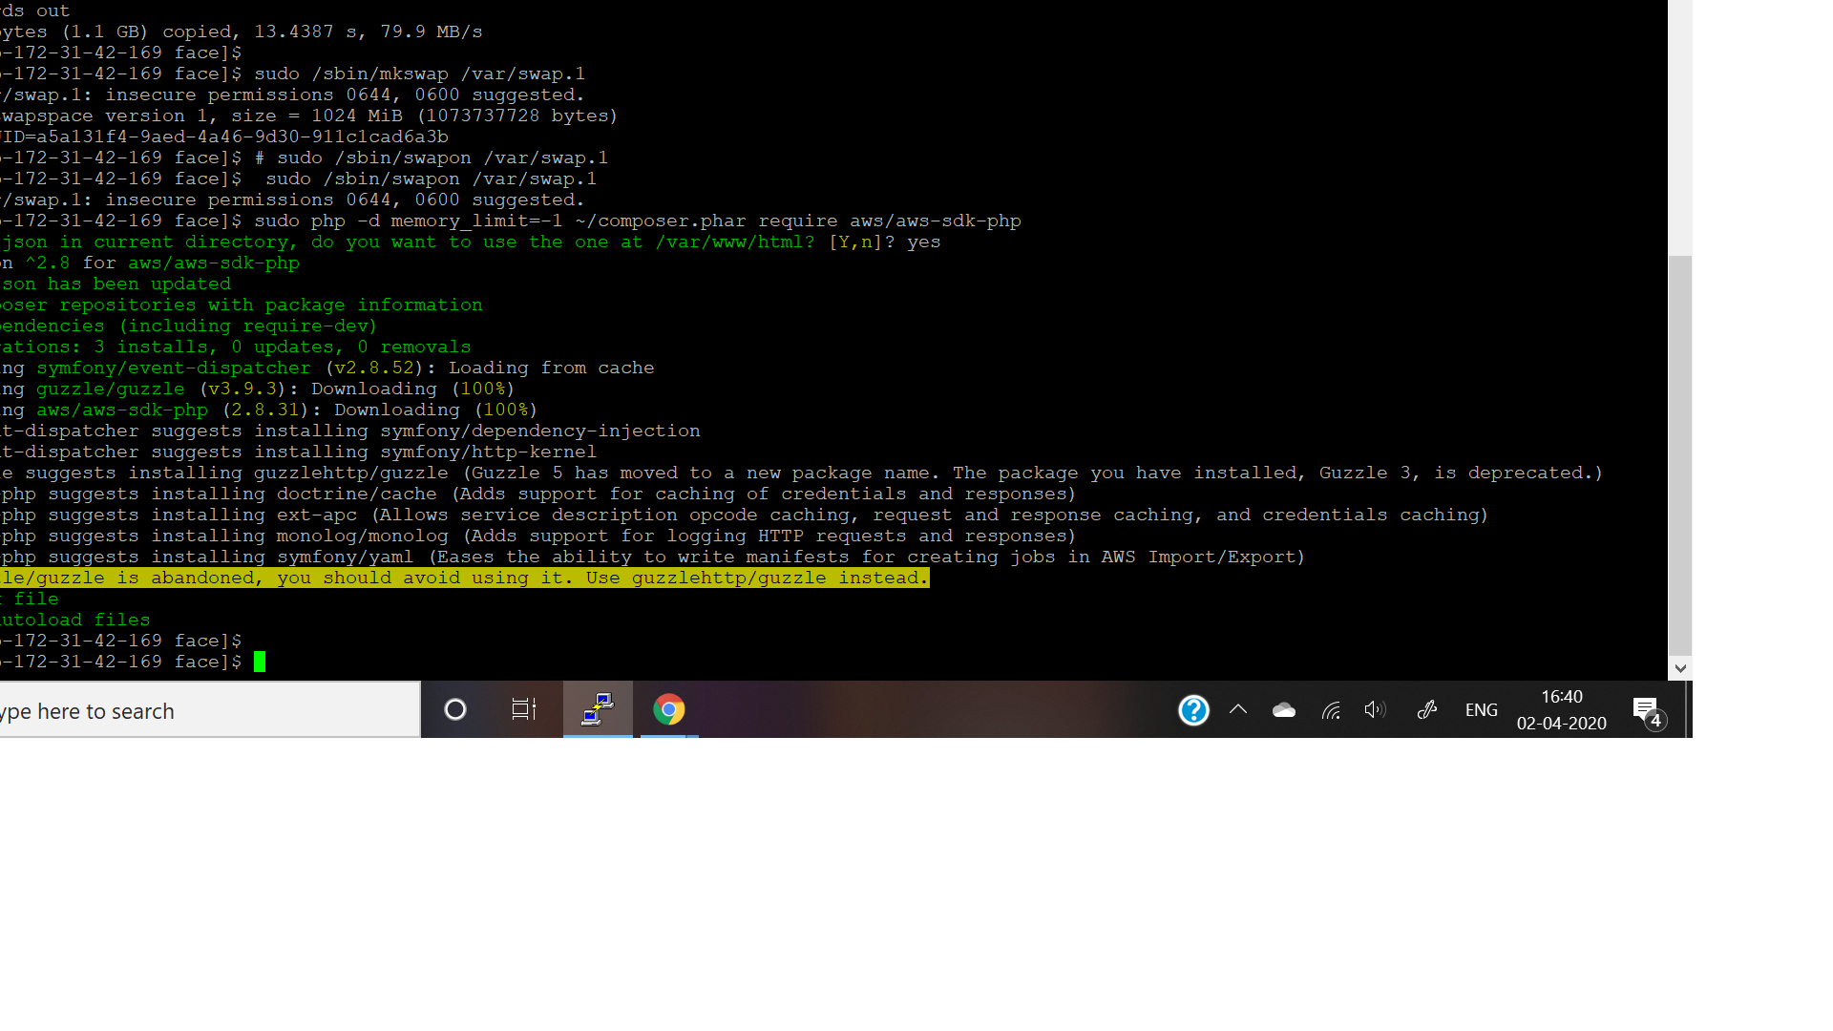

Installing php:

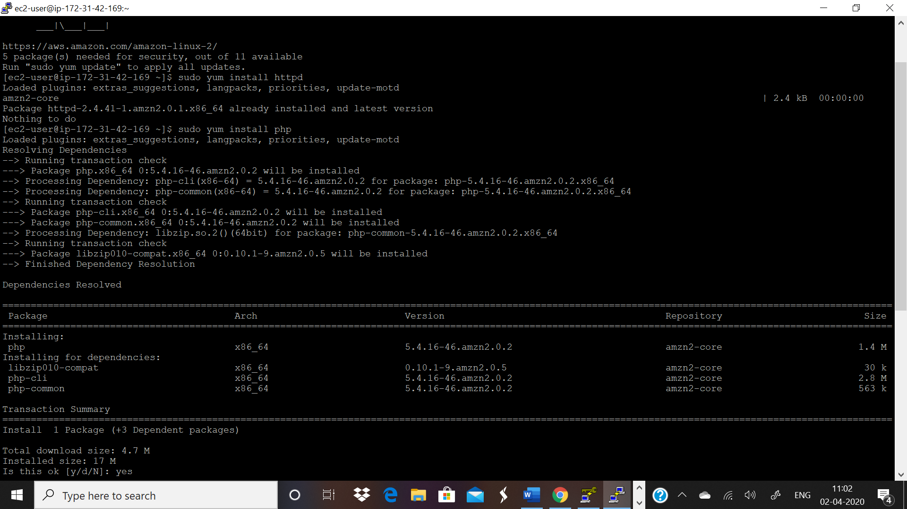

Index .php file code:

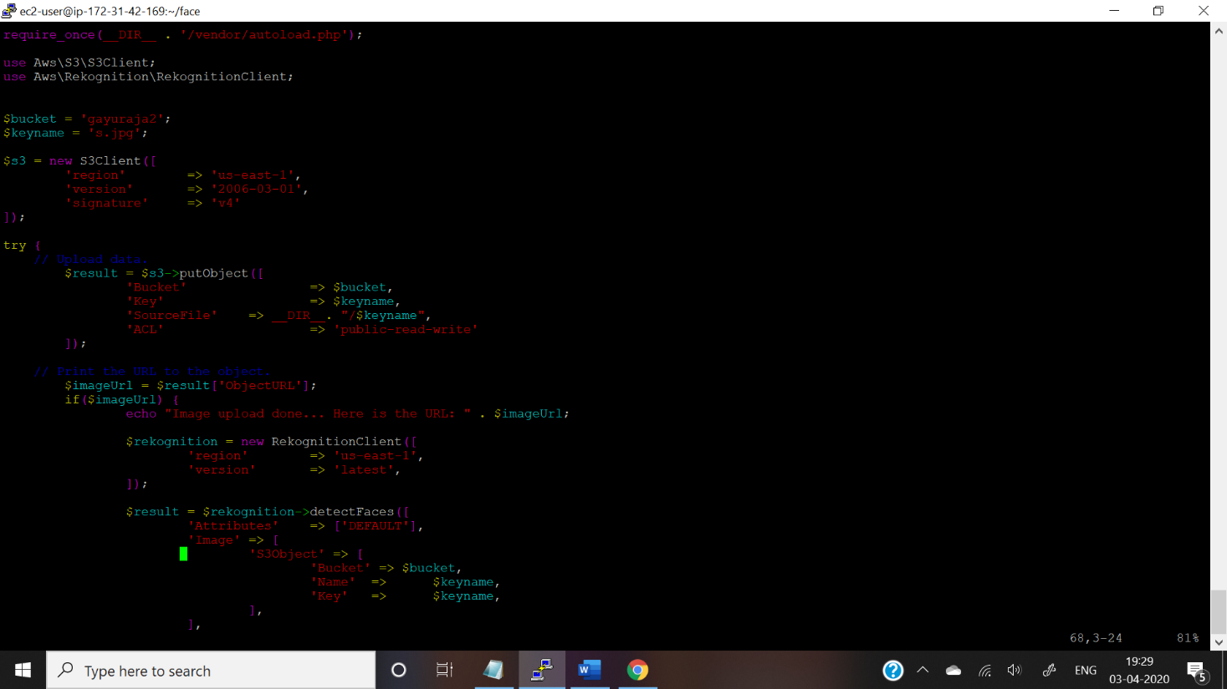

Upload successfully:

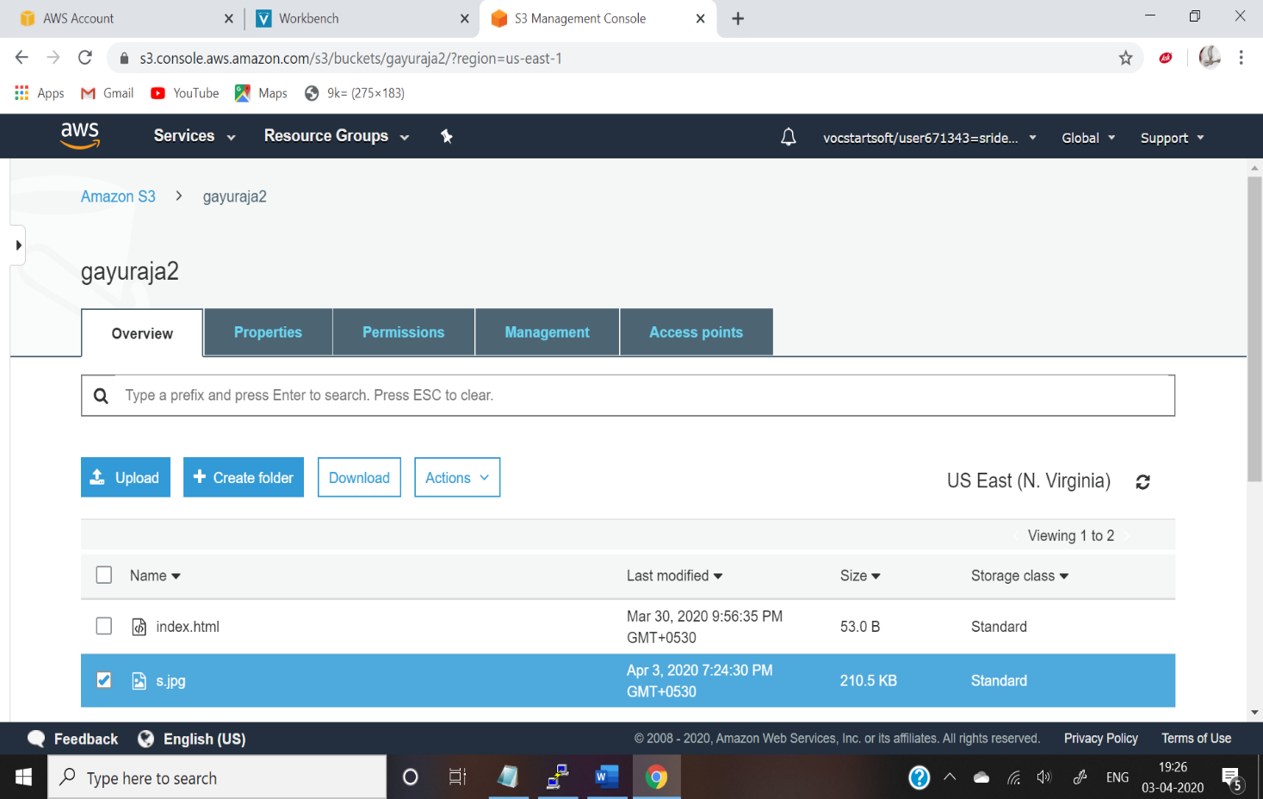

Ec2 and Rekoginition:

* Face detection app success

